AI WeatherWise
Team ID | SWTID-2026-9722
Project Name | AI Weatherwise
Team Leader | FATHIMA AZKIYA S I
Team Members | SHERENE FATHIMA J, AASHIMA K, ARYA E.
College Name | SRI KANYAKA PARAMESWARI ARTS & SCIENCE COLLEGE FOR WOMEN
Demo Video Link | https://drive.google.com/file/d/19CKy8Rvsw7QsSdBjXtrL50VtYR67lBBL/view?usp=drive_link

Overview
AI WeatherWise is a production-ready RESTful backend API built with Node.js and Express.js. It uses MongoDB with Mongoose for data storage, incorporating user authentication via JWT and password encryption via bcryptjs.
The application integrates the Google Gemini AI SDK (@google/genai) to produce intelligent activity recommendations and plain-language weather summaries derived from real-time environmental data. It also features a rule-based fallback engine to guarantee uninterrupted uptime even if external APIs or network connectivity are limited.

Technical Specifications
- Operating System: Windows 10/11, macOS, or Linux (cross-platform compatible).
- Runtime Environment: Node.js (v16+) using standard CommonJS module syntax.
- Package Manager: npm (v8+).
- Core Libraries & Tools:
  - express — Web framework and routing engine.
  - mongoose — Object Data Modeling (ODM) layer for MongoDB.
  - bcryptjs — Password hashing.
  - jsonwebtoken — State-free authorization tokens.
  - cors — Cross-Origin Resource Sharing handling.
  - dotenv — Centralized environment variables manager.
  - @google/genai — Generative AI client for Gemini model integration.
  - nodemon — Dev tool for automatic server reloads.
- Database Engine: MongoDB Atlas or local MongoDB instance.
- API Testing Tool: Postman or VS Code Thunder Client extension.

Epic 1: Project Architecture

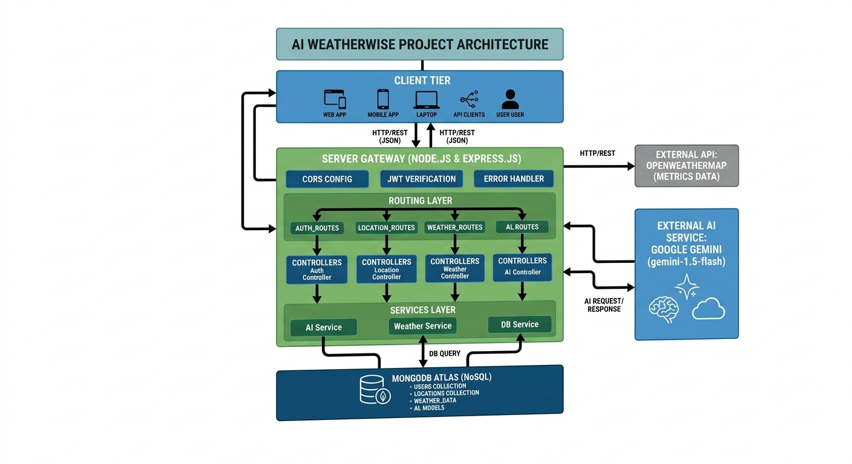

Architectural Patterns
- MVC Design Pattern: Separates database entities (Models), operational orchestration (Controllers), and application endpoints (Routes/Views).
- Layered Service Architecture: Decouples raw business and external integration logic (Services) from HTTP endpoint management (Controllers).
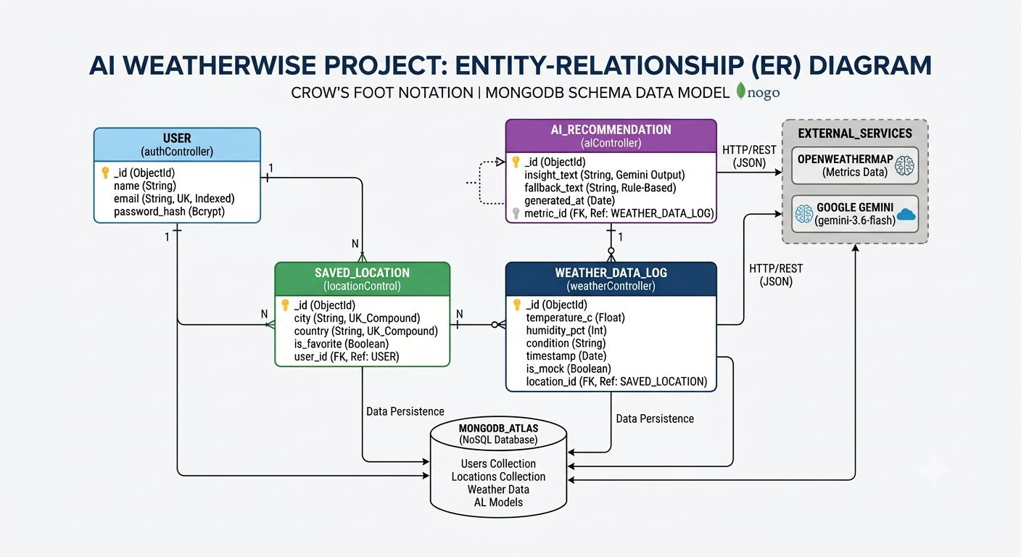

Component Breakdown
- Client Tier: Interface layer where API tools (Postman, Thunder Client) or web applications send HTTP REST requests containing JSON payloads.
- Server Gateway: Express application entry point that monitors dedicated ports, processes middleware, parses incoming JSON data, and delegates requests.
- Middleware Layer:
  - CORS Config: Configures cross-origin permissions.
  - authMiddleware: Checks authorization header presence, strips the Bearer token, verifies token signatures, and attaches the user payload to the request object.
- Controllers: Request/response orchestrators that extract input parameters, run validation, delegate work to services, and send standard JSON status codes.
- Services Layer: Contains core business logic:
  - weatherSvc: Queries live weather metrics or returns realistic mock values if external calls fail.
  - aiService: Prepares prompt templates, calls the Gemini API (gemini-3.6-flash), and invokes deterministic rules if the AI provider is unreachable.
- Data Tier: MongoDB engine managing persistence via strict schema interfaces.

Data Schemas & Model Definitions

1. User Entity Schema
- Fields:
  - name — String, required, trimmed whitespace.
  - email — String, required, unique index, lowercased, validated against standard email regular expression regex.
  - password — String, required, minimum length of 6 characters.
  - timestamps — Automatically creates createdAt and updatedAt records.
- Key Logic: Password hashing using a pre-save hook with bcryptjs (salt factor 10). A custom schema method matchPassword compares plain text input with stored hashes during authentication.

2. Location Entity Schema
- Fields:
  - city — String, required, trimmed.
  - country — String, required, trimmed.
  - user — Mongoose ObjectId referencing the User model, required.
  - timestamps — Creates automatic timestamp records.
- Key Index: Compound unique index on the combination of user, city, and country to prevent a single user from saving duplicate locations.

Complete API Route & Endpoints Summary
- Authentication Endpoints (/api/auth)
  - POST /register: Receives name, email, and password. Validates uniqueness, saves user, generates JWT signed with JWT_SECRET, and returns user details alongside token.
  - POST /login: Receives email and password. Verifies credentials, generates a new JWT token, and returns user session details.
- Location Endpoints (/api/locations - Guarded)
  - GET /: Fetches all saved favorite cities for the logged-in user.
  - POST /: Receives city and country. Connects the location to the authenticated user ID and saves it in MongoDB.
  - DELETE /:id: Deletes a specific favorite location by ID, ensuring it belongs to the requesting user.
- Weather Endpoints (/api/weather)
  - GET /:city: Fetches weather metrics (temperature, humidity, wind speed, condition) for a city. If an API key is absent, returns pre-formatted structured mock data.
- AI Insight Endpoints (/api/ai)
  - POST /weather-recommendation: Receives city, temperature, humidity, and condition. Calls Google Gemini via aiService to generate natural language clothing/activity advice.

Epic 2: Directory & Setup Structure
Plaintext
WEATHER/
├── src/
│ ├── config/
│ │ └── db.js # Database connection setup
│ ├── controllers/
│ │ ├── aiController.js # Handles AI recommendation calls
│ │ ├── authController.js # User registration and login logic
│ │ ├── locationController.js # CRUD for favorite locations
│ │ └── weatherController.js # Weather fetching handlers
│ ├── middleware/
│ │ └── authMiddleware.js # JWT token validation shield
│ ├── models/
│ │ ├── Location.js # Mongoose location model
│ │ └── User.js # Mongoose user model
│ ├── routes/
│ │ ├── aiRoutes.js # AI endpoints routing
│ │ ├── authRoutes.js # Auth endpoints routing
│ │ ├── locationRoutes.js # Location endpoints routing
│ │ └── weatherRoutes.js # Weather endpoints routing
│ ├── services/
│ │ ├── aiService.js # Gemini integration & fallbacks
│ │ └── weatherService.js # Weather API integration
│ ├── app.js # Express app middleware setup
│ └── server.js # Server startup entry point
├── .env # Environment secret variables
├── .gitignore # Excluded files list
├── package.json # Dependencies list
├── package-lock.json # Locked dependency versions
├── postman_collection.json # API test collection
└── README.md # Documentation file

Epic 3 & 4: Deep-Dive Code Explanation

1. Main Entry Point (server.js & app.js)
- Core Logic: The initialization workflow is divided into server bootstrapping (server.js) and middleware mounting (app.js).
- Server Script (server.js): Invokes connectDB() to connect to MongoDB first. Once connected, app.listen(PORT) starts listening for requests. If the connection fails, it catches the error and exits with process code 1.
- Application Script (app.js): Loads express(), mounts cors() and express.json() parsers, then mounts route paths:
  - Mounts /api/auth mapped to authRoutes.
  - Mounts /api/locations mapped to locationRoutes.
  - Mounts /api/weather mapped to weatherRoutes.
  - Mounts /api/ai mapped to aiRoutes.

2. Database Connection (src/config/db.js)
- Core Logic: Imports mongoose and defines an async function connectDB. It uses mongoose.connect() targeting process.env.MONGO_URI with a fallback connection string mongodb://127.0.0.1:27017/weatherwise. It logs success or errors and exits execution if connection fails.

3. Authentication Middleware (src/middleware/authMiddleware.js)
- Core Logic: Extracts the Authorization header from incoming requests. Checks if it starts with the word Bearer . It extracts the raw token, verifies it using jwt.verify(token, process.env.JWT_SECRET), extracts the decoded user ID, and attaches the user record (excluding password) to req.user. If validation fails, it yields a 401 Unauthorized response.

4. Controller Workflows
- Authentication Controller (authController.js):
  - Register: Checks if email exists using User.findOne(). Creates a new user record using User.create(). Generates JWT token with jwt.sign() passing user ID payload, secret, and expiration (e.g., 30d). Returns 201 Created with token and user object.
  - Login: Finds user by email. Calls user.matchPassword() to compare hashed passwords. If matched, returns 200 OK with token and profile data; otherwise returns 401.
- Location Controller (locationController.js):
  - Add Location: Reads city and country from body. Saves location using Location.create() associated with req.user._id.
  - Get Saved Locations: Calls Location.find({ user: req.user._id }) to fetch stored cities for the authenticated user.
- AI Controller (aiController.js):
  - Reads environmental parameters (city, temperature, humidity, condition) from request body. Passes data to aiService.generateRecommendation(), yielding AI output directly back to client.

5. Services Engine (aiService.js)
- Core Logic: Initializes Google Gen AI client using @google/genai with process.env.GEMINI_API_KEY.
- Prompt Engineering: Constructs a structured system prompt instructing the model to generate concise 1–2 sentence outdoor and clothing advice based on temperature, humidity, and condition metrics.
- Fallback Architecture: Wraps API execution in a try/catch block. If the API key is missing or the external service fails, execution moves to a deterministic fallback function that evaluates temperature ranges (e.g., if temp > 30°C: "Stay hydrated and wear light cotton clothes.") ensuring reliable API responses.

Epic 5: Execution & API Usage Examples

How to Run locally
- Install project dependencies: npm install
- Configure .env file with proper secrets
- Run developmental server: npm start

Request & Response Flow Examples

1. Register Account
- Endpoint: POST /api/auth/register
- Request Body:
  - name: "John Doe"
  - email: "john@mail.com"
  - password: "123456"
- Response Body (201 Created):
  - Contains success: true flag.
  - Contains user record with generated _id, name, email, and signed token string.

2. Get Weather Metrics
- Endpoint: GET /api/weather/bangalore
- Response Body (200 OK):
  - success: true
  - data: Object containing city ("Bangalore"), temperature (34), humidity (79), windSpeed (12), condition ("Windy"), and isMock boolean flag.

3. AI Weather Recommendation
- Endpoint: POST /api/ai/weather-recommendation
- Request Body:
  - city: "Bangalore"
  - temperature: 34
  - humidity: 79
  - condition: "Windy"
- Response Body (200 OK):
  - success: true
  - recommendation: "Stay hydrated, and wear light cotton clothes."

PROJECT OVERVIEW:
App.js:
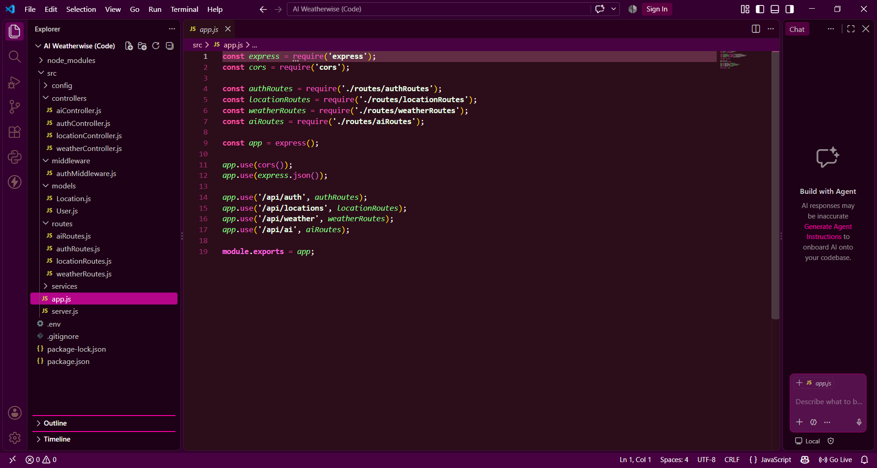
Server.js:
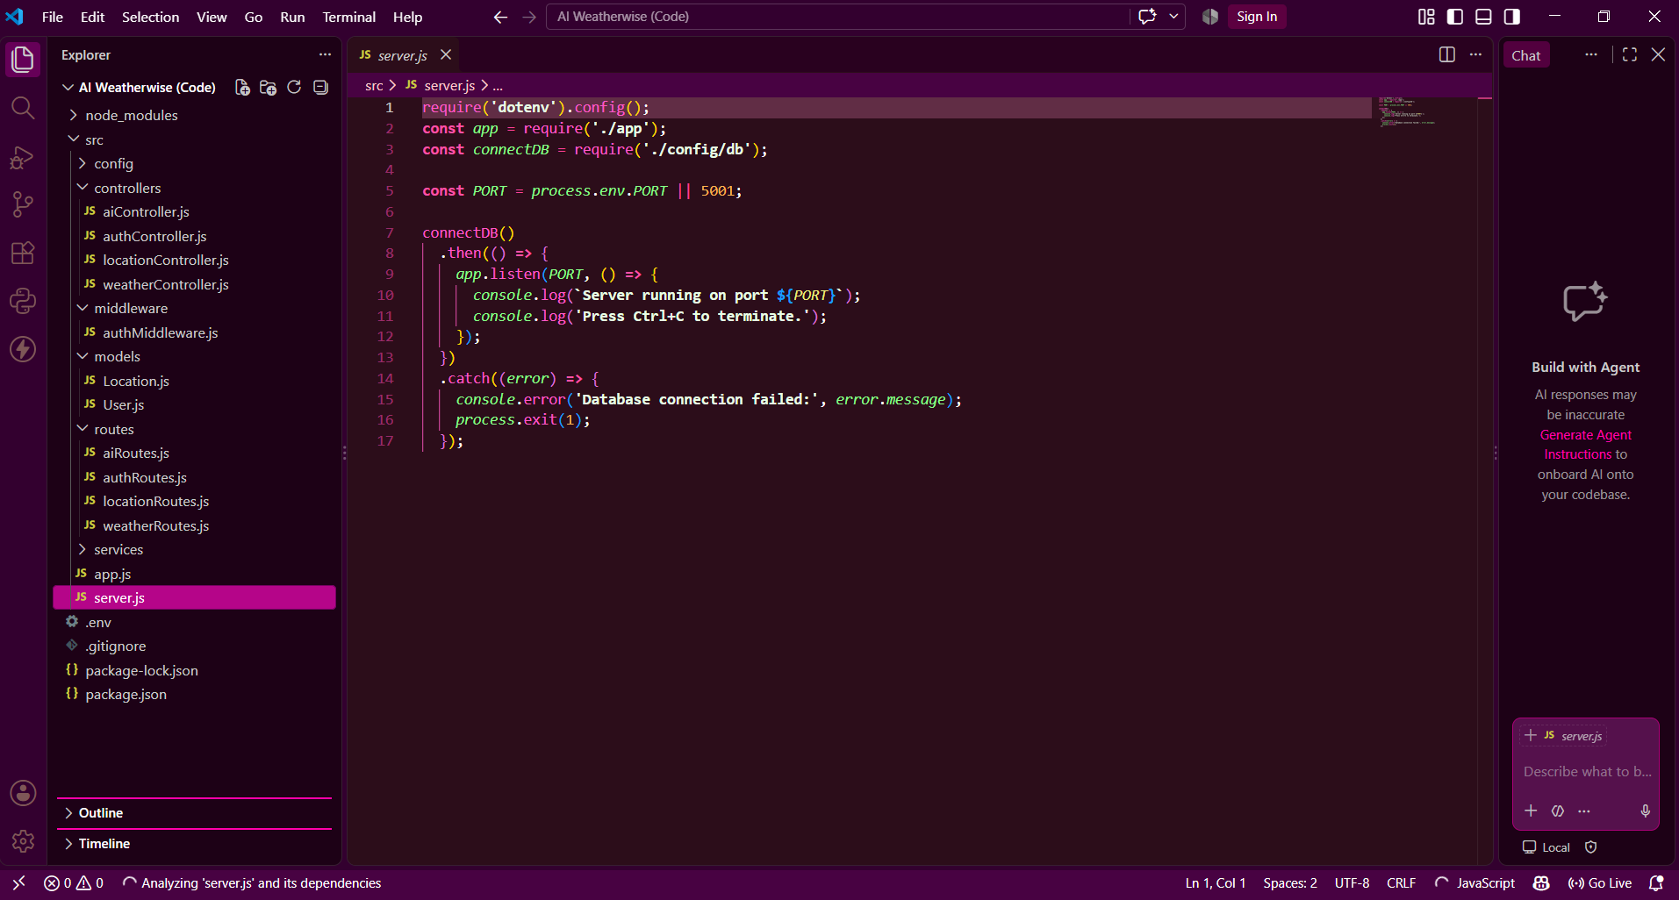
User Already Exists Error:
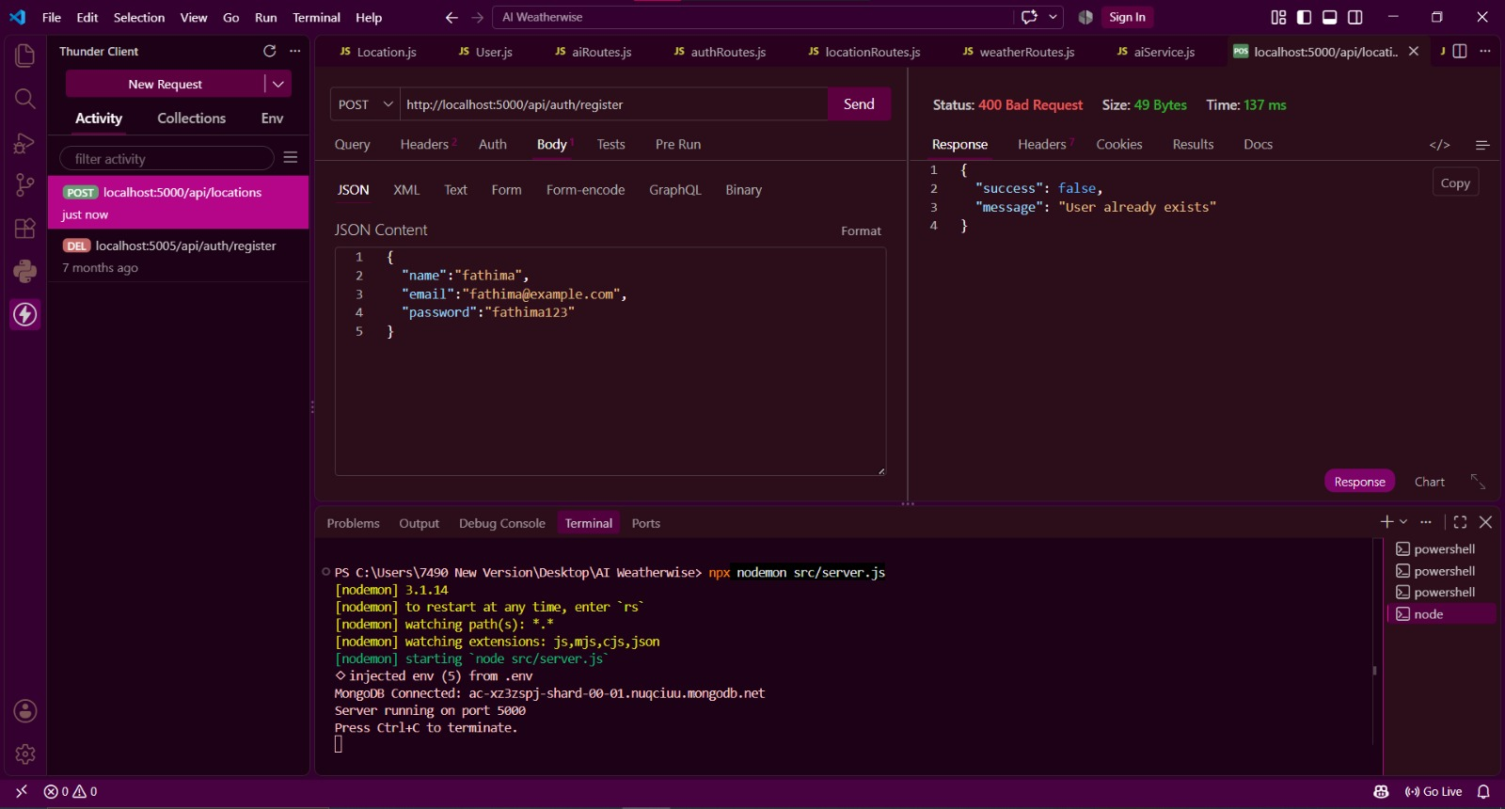

Invalid Credentials Error:
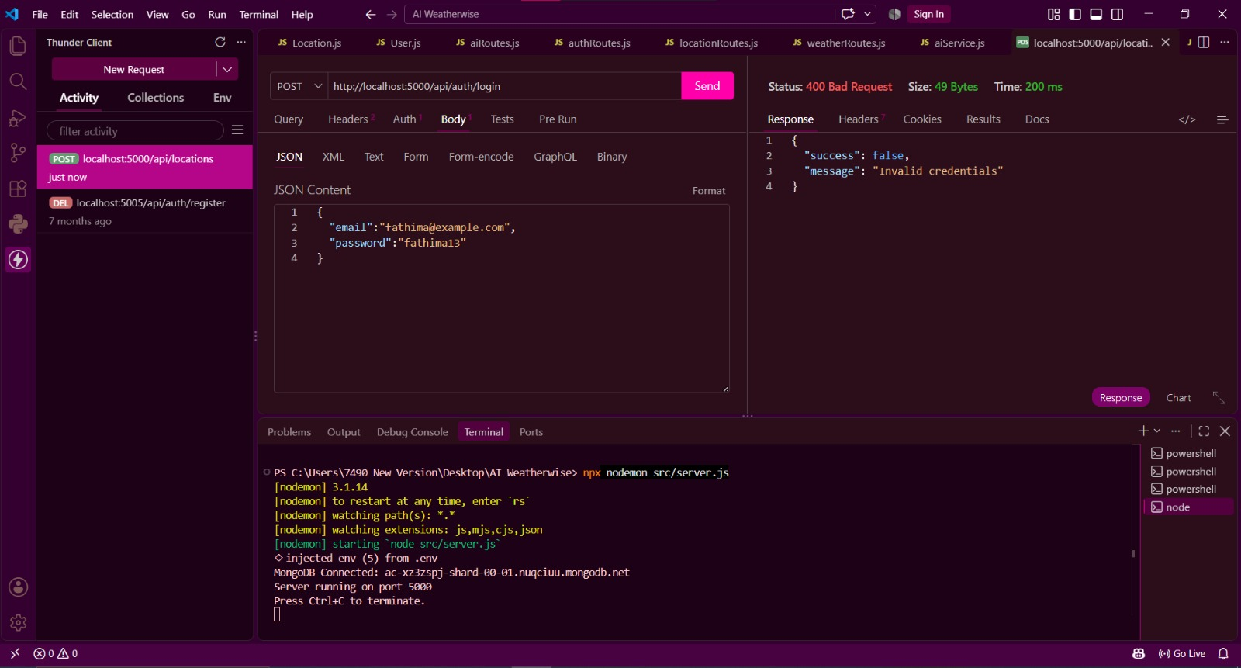
REGISTRATION:
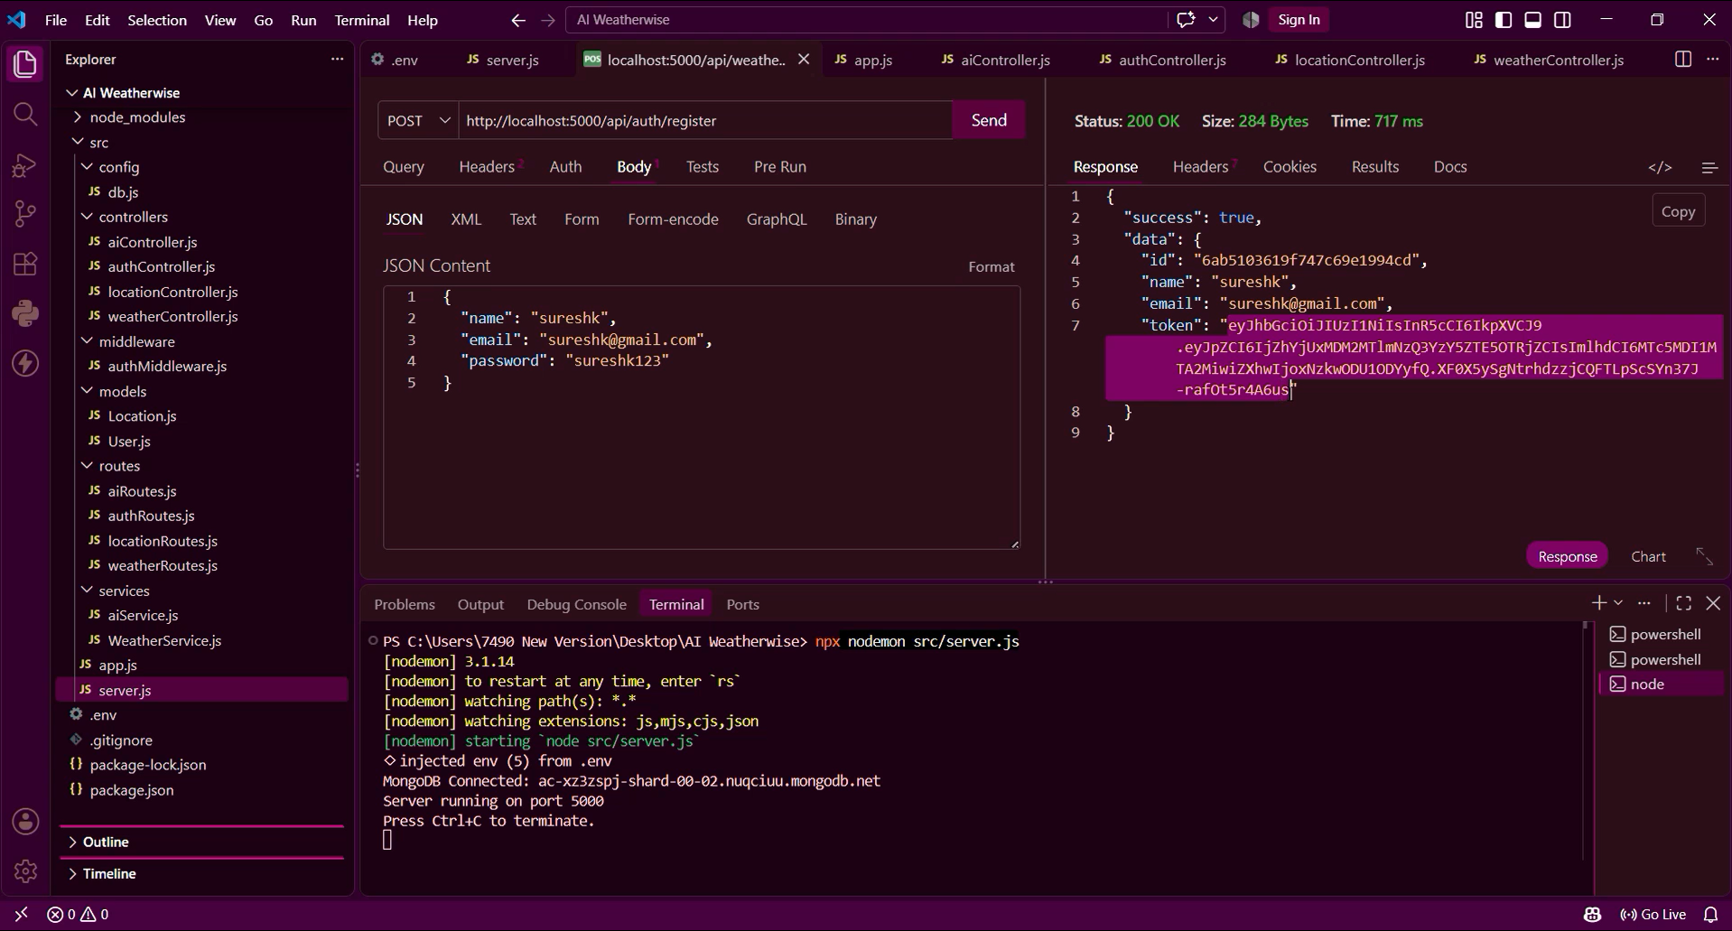

LOGIN:
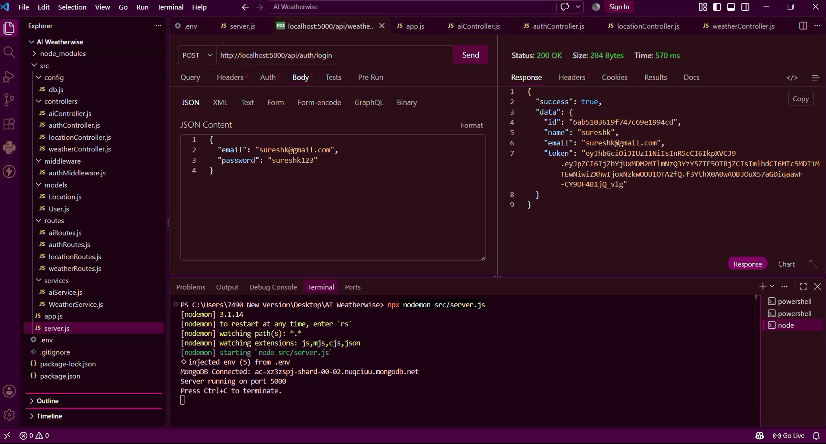
WEATHER RETRIVAL:
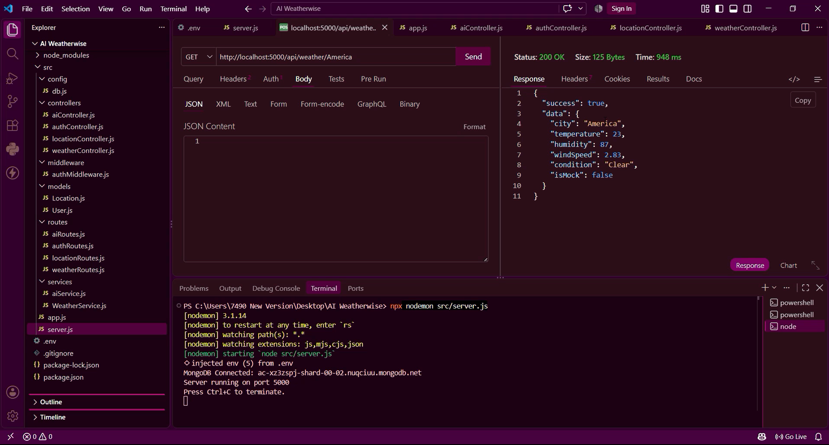

ADD FAVORITE LOCATION:
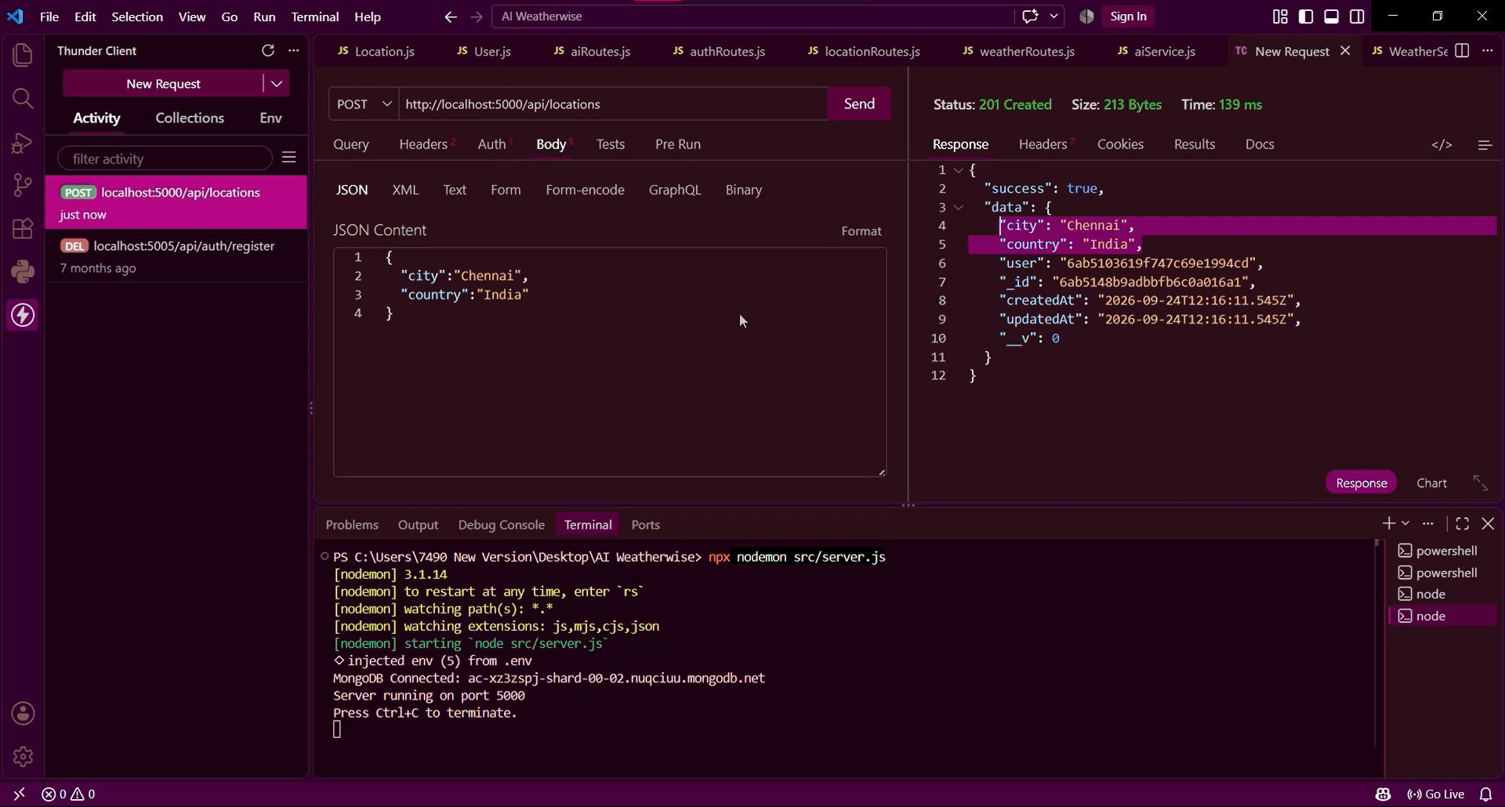
VIEW FAVORITE LOCATION:
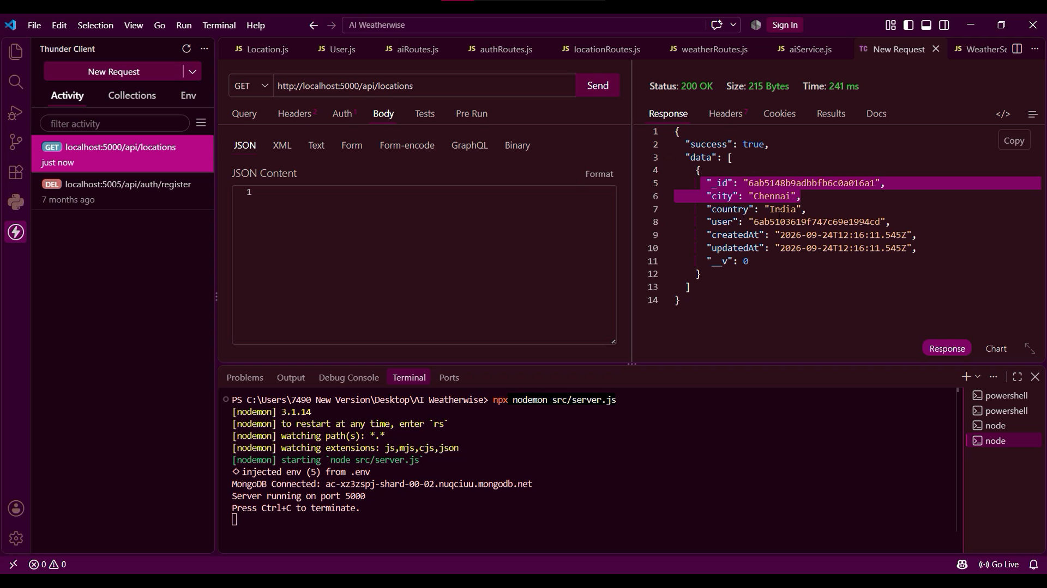

USER IN MONGODB:
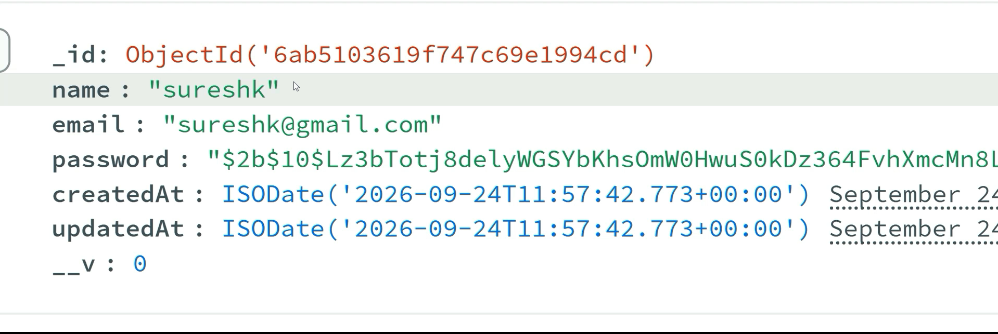
FAVORITE LOCATION IN MONGODB:
